1. **Write a python script to encrypt the string using Caesar cipher.**

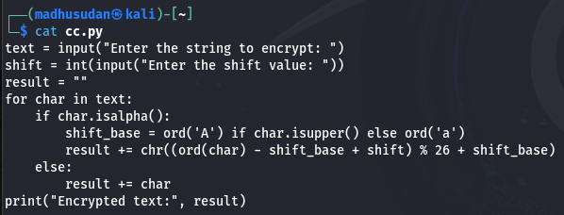

**Output**

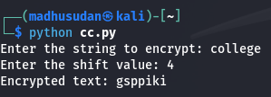

1. **Write a Python script to Modify the above script to shift cipher based on user choice.**

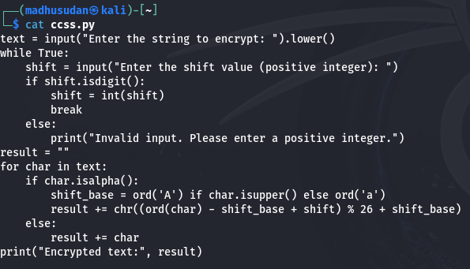

**Output**

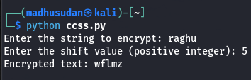

**3. Write a Python script to convert cipher text into uppercase characters and split the cipher into group of 5 of characters.**

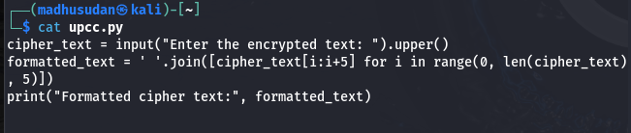

**Output**

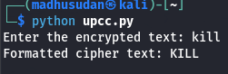

1. **Write a Python program to Find the histogram for each characters.**

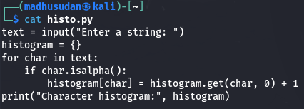

**Output**

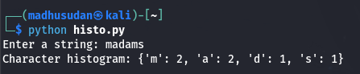

1. **Write a Python script to read the contents from the file.**

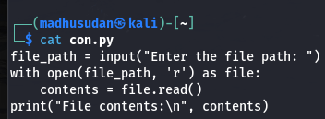

**Output**

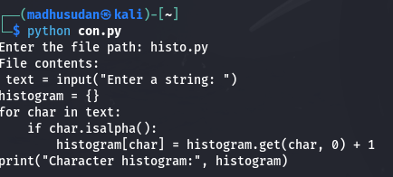

1. **Write a Python script to encrypt the contents from the file.**

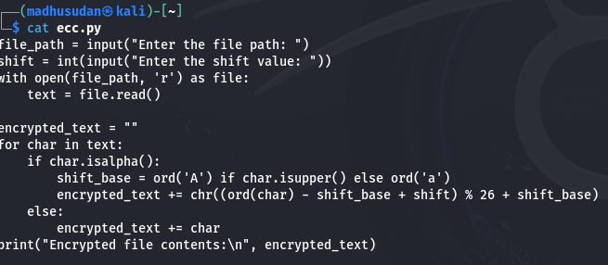

**Output**

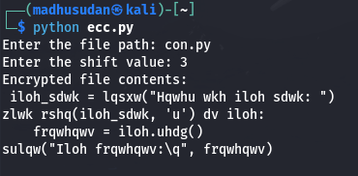

**7. Do validation to the python program (2)**

**- not to accept special characters**

**- not to accept numeric values**

**- not to accept empty value**

**- accept only string**

**- string should be lowercase if not convert the case**

**8. Write a Python program to checks if two given strings are anagrams of each other.**

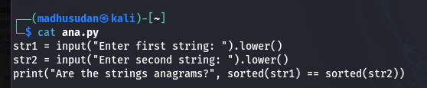

**example: mug, gum**

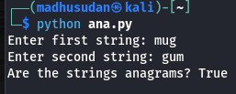

**output**

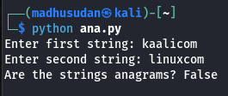

**9. Write a Python program to check the given string is palindrome or not**

**Do not use built in functions**

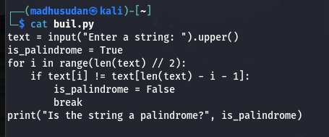

**Output**

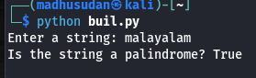

**Example: MADAM**

**RACECAR**

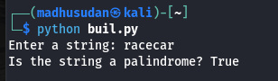

**LEVEL**

**CIVIC**

**10. Write a Python program to check if a substring is present in a given string.**

**Example: Understand – stand**

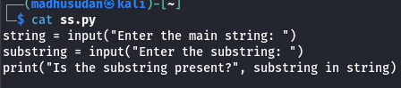

**Output**

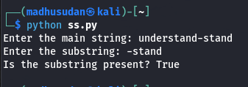

**11. Explore string module**

**import the string module in your python script.**

**print all the lowercase characters**

**print all the uppercase characters**

**print all the lowercase and uppercase characters**

**print all the digits**

**print all the punctuation symbols**

**count the total number of punctuation symbols**